IT department / Mutah university
Image processing lab 3

Problem 1: histogram equalization

Problem 2: histogram matching
Problem 3: weighted average filter
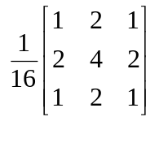
Do the average filter
Do the median filter
Do the max filter
Do the min filter
Compare all
Do laplacian filter
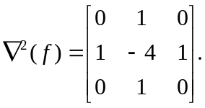
Do difference operator
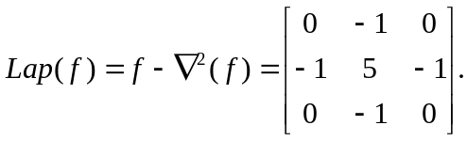
Compare between both
Problem 4:

